STICK 2 ALL PURPOSE CONTACT ADHESIVE

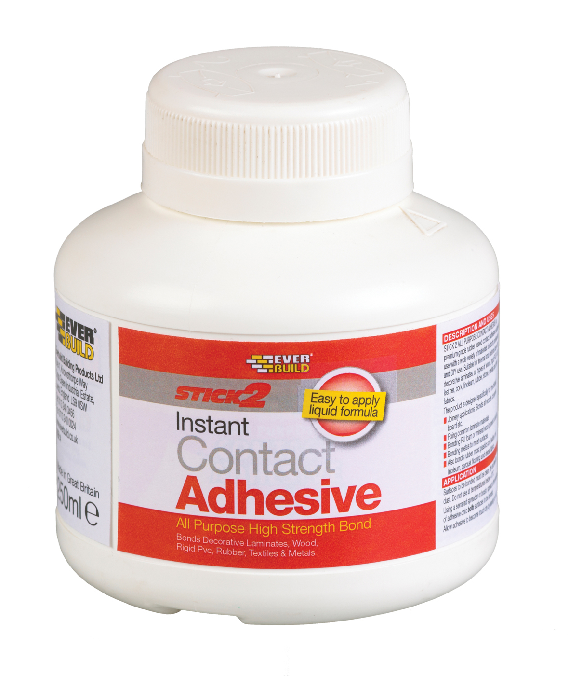
Colour | Product Code | Pack Size | Box Qty
Beige | CON125 | 125ml | 10
Beige | CON250 | 250ml | 12
Beige | CON750 | 750ml | 12
Beige | CONA5 | 5Ltr | 4

Product Description
STICK 2 ALL-PURPOSE CONTACT ADHESIVE is a brushable, general purpose contact adhesive with fast setting properties coupled with long open time.

Benefits
- Excellent adhesion - adheres to most common surfaces.
- Exceptional bond strength - out performs conventional wood glues.
- Internal and external use (excluding 5ltr size) - excellent weathering and aging properties.

Areas For Use
- Laminate materials
- Bonding pu foam or mineral wool panels to plasterboard.
- Bonding metals to most surfaces.
  - Bonds wood, rubber, most plastics and leather, cork, lino, rigid PVC, dense

Limitations
- Do not use on soft (plasticised) PVC.
- Do not use on polystyrene.
- Do not use on bitumen, asphalt or cellulose painted surfaces.
- Do not use on bitumen or tar leaching products.
- Do not use as a mirror adhesive as the product may attack the mirror backing.
- Do not expose bonded areas to direct sunlight for three days after fixing.
- Do not use in areas subject to continuous water immersion.
- Always allow the adhesive to become touch dry on both surfaces before bringing surfaces together – premature bonding will cause solvent entrapment and blistering of laminates.
- At low temperatures, care must be taken to ensure that the temperature of the adhesive and of both surfaces to be bonded is higher than the ambient temperature. Cold materials have a strong tendency to attract moisture present in the surrounding air, which can have a disastrous effect on the bond strength.

Surface Preparation
The surfaces to be glued should be clean and free from dust, grease and other contaminants. Materials should be stored in a warm environment prior to bonding to avoid chilling of the glue line, which leads to extended setting times and possible adhesion problems.

Application
Stir adhesive well before use. DO NOT USE BELOW 10°C.
The adhesive is applied to both surfaces in a thin coat using a short stiff brush or spreader. Allow the surfaces to become “touch dry” (adhesive is glossy and no longer transfers to the knuckles) for between 10 and 20 minutes. Porous surfaces must receive two coats, allowing the adhesive to dry between coats. Align the bond edges and bond under maximum pressure. For best results, laminates should be nip rolled or pressed. If this is not possible, use a hard roller and go over the entire surface using as much bodyweight as possible, working from the centre outwards. Seams and edges should also receive extra pressure.

The newly bonded material should not be subjected to extreme temperature changes for 3 to 4 days after bonding. Avoid further fabrication until the adhesive has fully cured.

Specific Data
Colour | Cream / Caramel
Base | Polychloroprene
Solids | 25 +/- 2%
Viscosity | 4500 +/- 1000 cps
Coverage | 2.5m² / litre
Tack Life | 5 – 30+ minutes
Flash Point | -35 to 0°C
Cleaner | Contact Adhesive Thinners

Health & Safety
Consult MSDS for full list of hazards.

Storage
Store in original unopened containers between 10 and 25ºC. Reseal immediately once used.

Shelf Life
24 months from date of manufacture in original unopened containers.

The technical data contained herein is based on our present knowledge and experience and we cannot be held liable for any errors, inaccuracies, omissions or editorial failings that result from technological changes or research between the date of issue of this document and the date the product is acquired. Before using the product, the user should carry out any necessary tests in order to ensure that the product is suitable for the intended application. Moreover, all users should contact the seller or the manufacturer of the product for additional technical information concerning its use if they think that the information in their possession needs to be clarified in any way, whether for normal use or a specific application of our product. Our guarantee applies within the context of the statutory regulations and provisions in force, current professional standards and in accordance with the stipulations set out in our general sales conditions. The information detailed in the present technical data sheet is given by way of indication and is not exhaustive. The same applies to any information provided verbally by telephone to any prospective or existing customer.

